Biology – Mrs. Michaelsen
Unit 2 - Chemical Reactions and Enzymes Review

In every human cell, thousands of chemical reactions essential to life occur every second. Enzymes control the rate of these reactions. The sum of all the chemical reactions within a cell is what we call metabolism.

Metabolism in its entirety is complex. It consists of pathways and cycles that may intersect and share intermediate compounds. Often, it involves reactions that occur one after the other in a linked fashion.

Anabolism: A type of metabolic process where larger molecules are constructed from smaller ones, absorbing energy (e.g. dehydration synthesis). Anabolism provides all the materials required for cellular growth and repair.

Catabolism: A type of metabolic process where larger molecules are broken down into smaller ones, releasing energy (e.g. hydrolysis). Hydrolysis uses a water molecule to break down, or decompose, carbohydrates, lipids, and proteins. Carbohydrates are broken down into monosaccharides, lipids into fatty acids and glycerol, and proteins into amino acids.

Examples of Anabolism and Catabolism in the Human Body

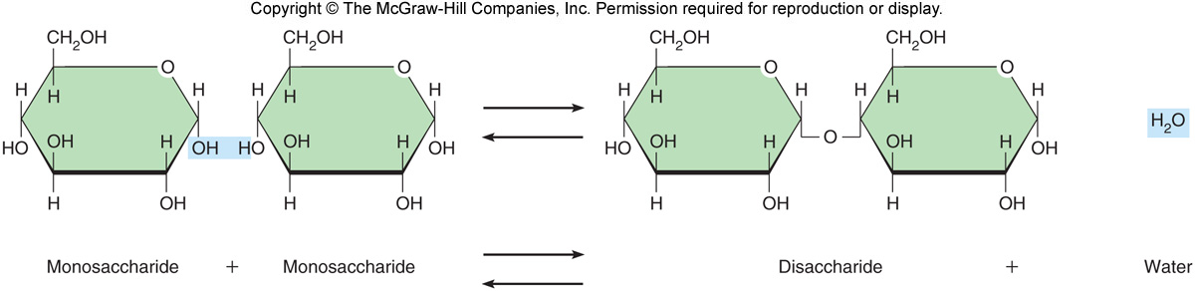
A disaccharide is formed from two monosaccharides in anabolism (arrows to the right). In the reverse, catabolism, a disaccharide is broken down into two monosaccharides (arrows to the left).

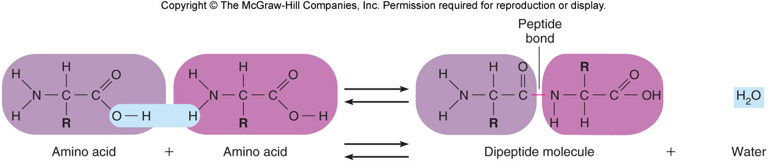

When anabolism unites two amino acid molecules, a peptide bond forms between a carbon atom and a nitrogen atom, resulting in a dipeptide molecule (arrows to the right). In the reverse reaction, catabolism, a dipeptide molecule is broken down into two amino acids (arrows to the left).
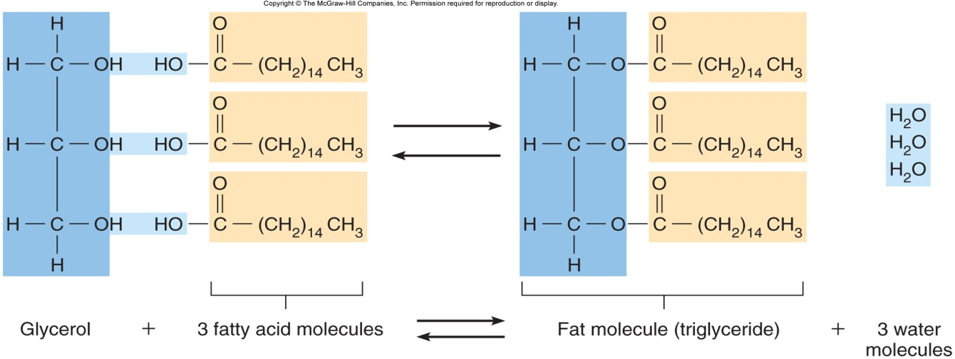

A glycerol molecule and three fatty acid molecules form a fat molecule (triglyceride) in anabolism (arrows to the right). In the reverse reaction, catabolism, a triglyceride is broken down into three fatty acids and a glycerol (arrows to the left).

Control of Metabolic Reactions

Metabolic reactions require energy (activation energy). Heat is often used in a laboratory because it increases the rate at which the molecules move and increases the likelihood of new electrons interacting and forming new bonds. The temperature within our cells is too mild to promote the reactions of life. Enzymes make these reactions possible.

Most enzymes are globular proteins that promote specific chemical reactions by lowering the activation energy required to start these reactions. They are only needed in small quantities, and are not consumed, so they function repeatedly.

Each enzyme is specific and acts on only one particular molecule called a substrate. For example, the substrate hydrogen peroxide (a toxic by-product of certain metabolic reactions), is broken down by the enzyme catalase (found in the liver and kidney) into water and oxygen. This action prevents an accumulation of hydrogen peroxide, which can damage cells.

2 H₂O₂ 2H₂O + O₂
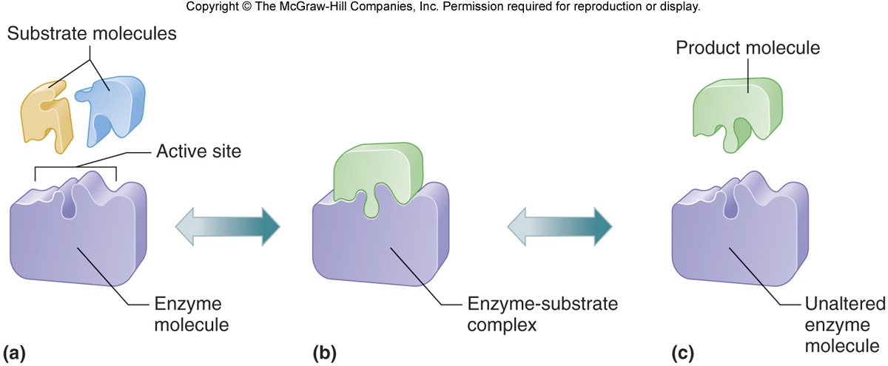

The action of the enzyme catalase is obvious when using hydrogen peroxide to cleanse a wound. Injured cells release catalase, and when hydrogen peroxide contacts them, bubbles of oxygen are set free. The resulting foam removes debris from inaccessible parts of the wound.

